Teclast Tutorial
How to upgrade firmware for your Teclast Tablet (UNISOC CPU)

Before proceeding with the firmware upgrade, please read these instructions carefully!
It's important to note that there are risks involved in flashing, and it can potentially clear all the data stored on your device. Therefore, it's essential to back up any important data before upgrading.
If there is a Micro SD card in the device, please remove it before beginning the upgrade.

Before starting the firmware update process, make sure to complete the following steps:
- Locate the ID number on the back of your device, which is comprised of 4 letters and numbers.
- Download the corresponding firmware package from the official Teclast website. (www.teclast.com) Navigate to the "Support" and "Software Download" sections of the website. Enter your device's ID number to search for and download the corresponding firmware package.
- Ensure that your device has at least 30% battery power.
- Turn off any antivirus software on your computer.

Once you have completed the preparatory work, you can proceed with the firmware upgrade process:
- Open the "Upgrade Driver" folder, install the corresponding driver version according to the computer system, install “32install.exe” for 32-bit system, install “64install.exe” for 64-bit system.
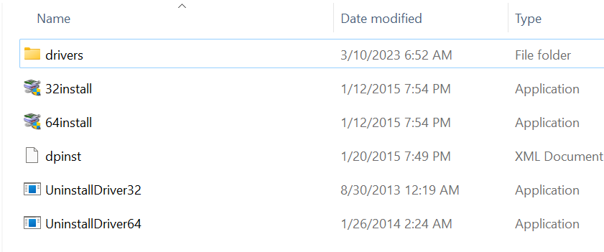

- When installing the driver, a prompt similar to the one shown below will appear. Select "Install" to proceed.
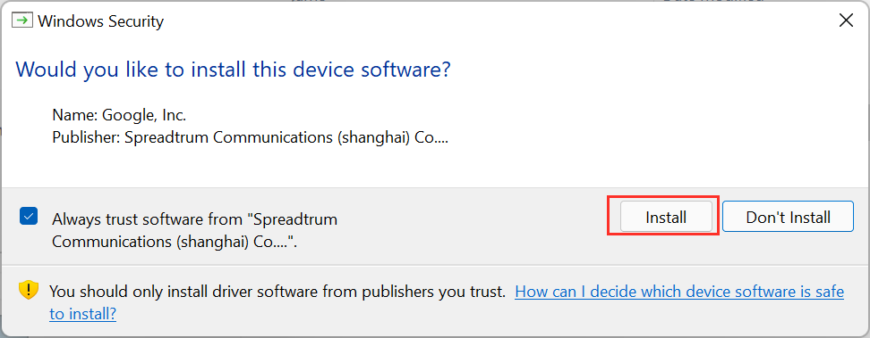

- After the installation is complete, a prompt similar to the following will appear. Click "Finish" to complete the installation.
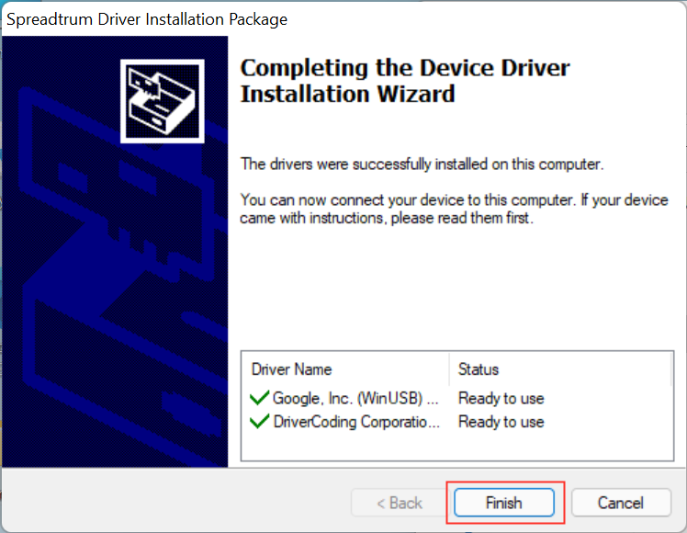

Install the Firmware:
- Open the "Upgrade Tools" folder, find and double-click on "UpgradeDownload.exe" to open the upgrade program.
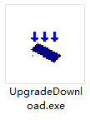

- The program interface is shown below.
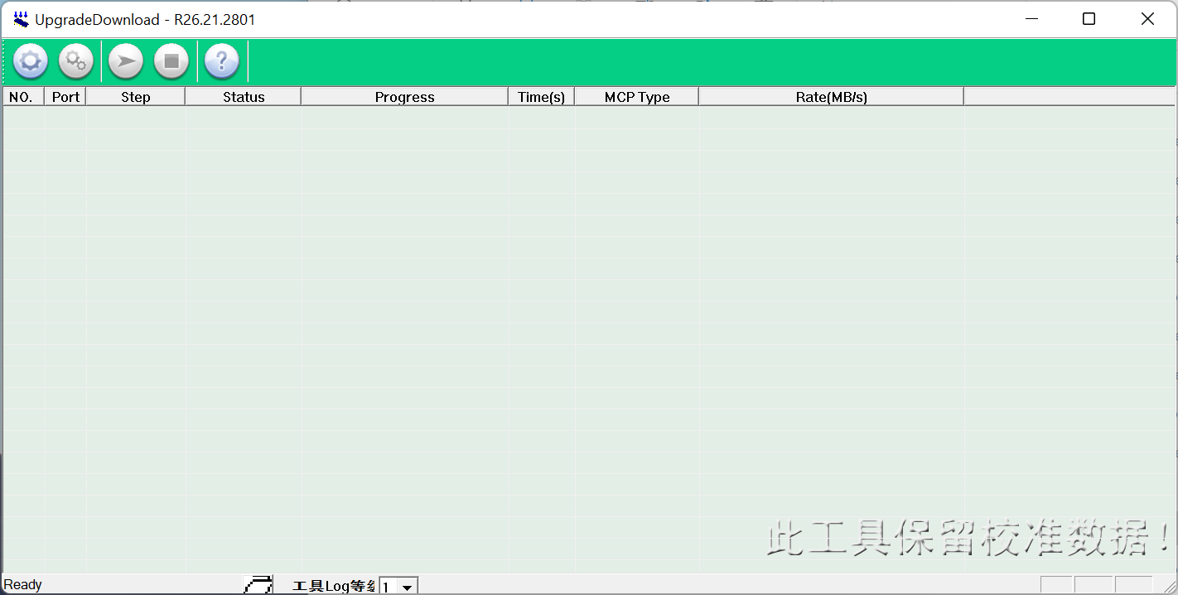

- Click this icon and open “Firmware.pac” in the “Firmware” folder.
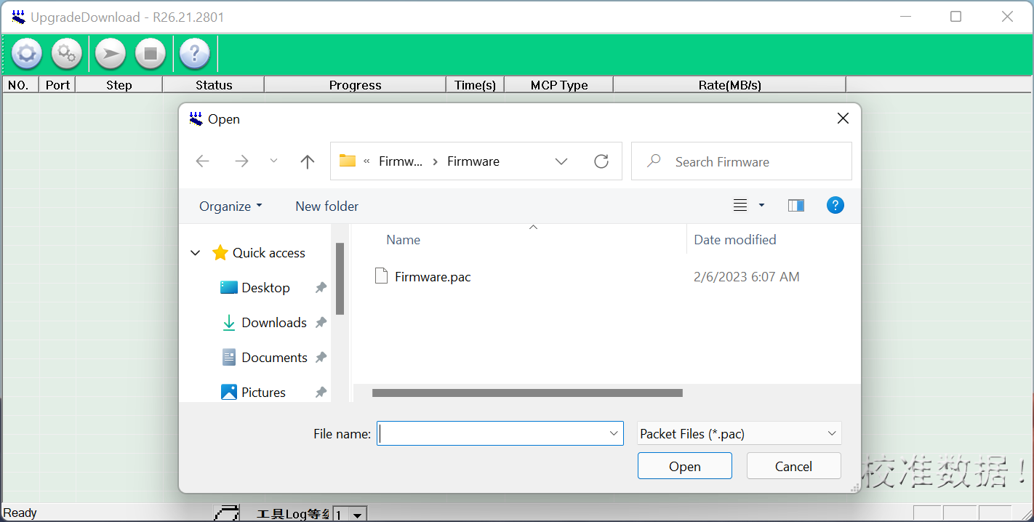

- Select the firmware program and wait for the firmware to finish loading. The loading progress will be indicated as shown in the following figure:
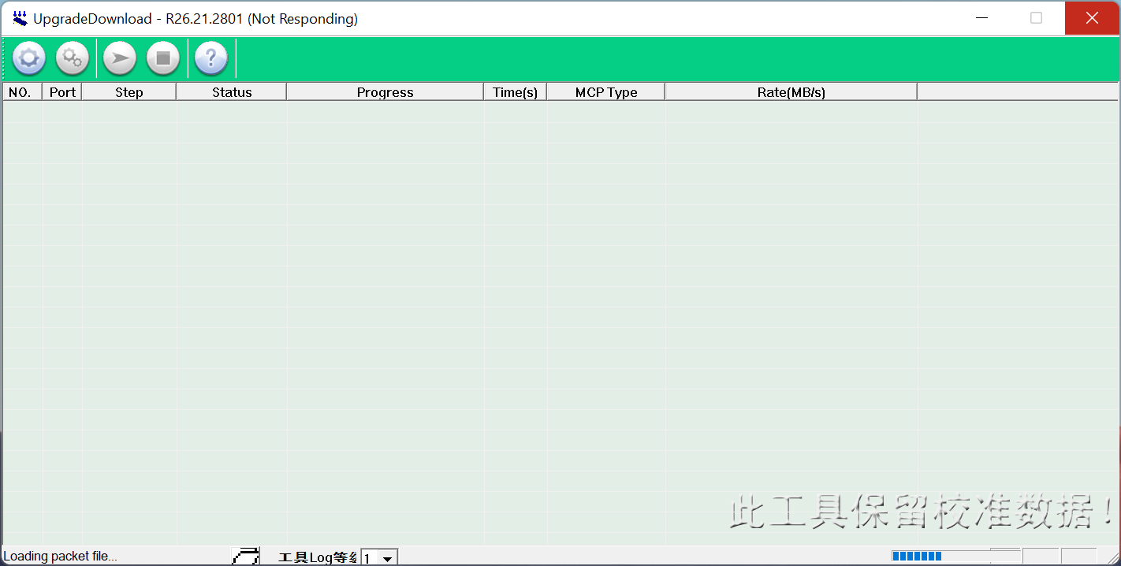

- When there is a “Ready” reminder in the lower left corner of the program interface that the firmware has been loaded.
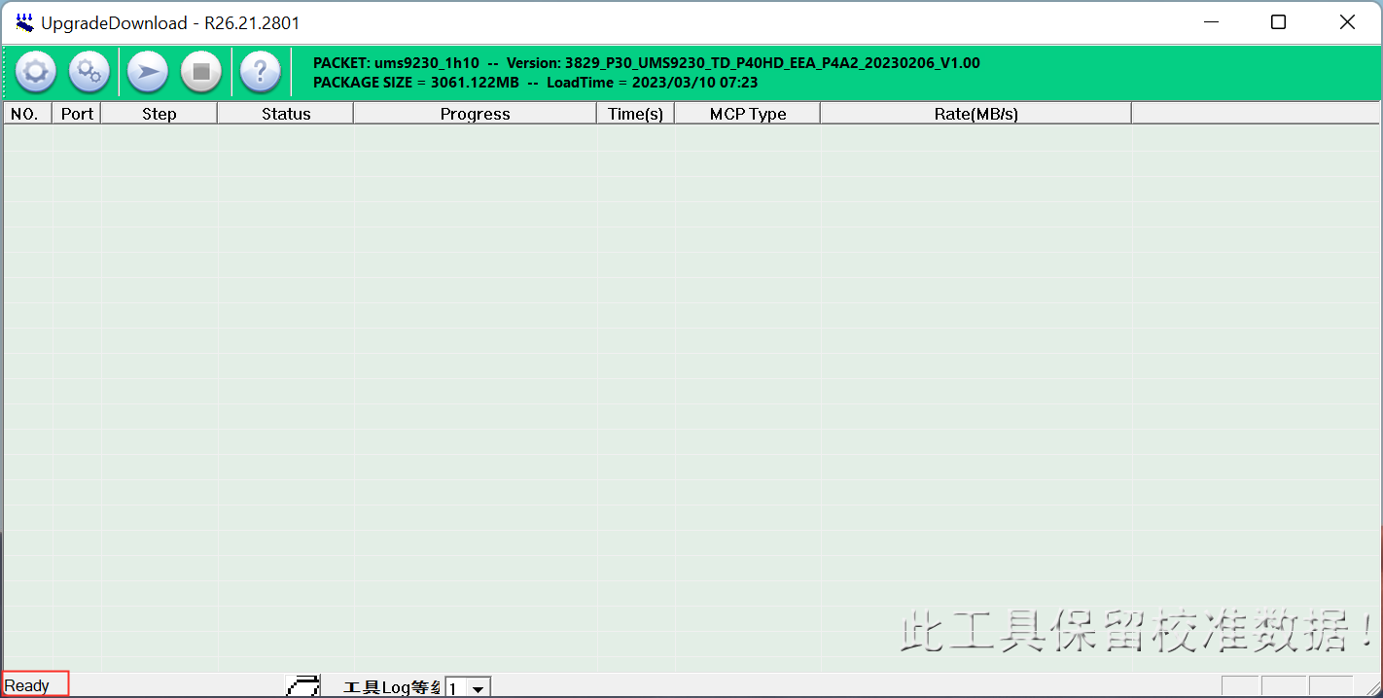

- Click the “Update” icon and hold down the VOLUME_DOWN of table then connect with computer. The tablet will start the installation automatically. The upgrade process is shown in the following figure. You can release the volume down button at this time and wait for the firmware upgrade to complete:
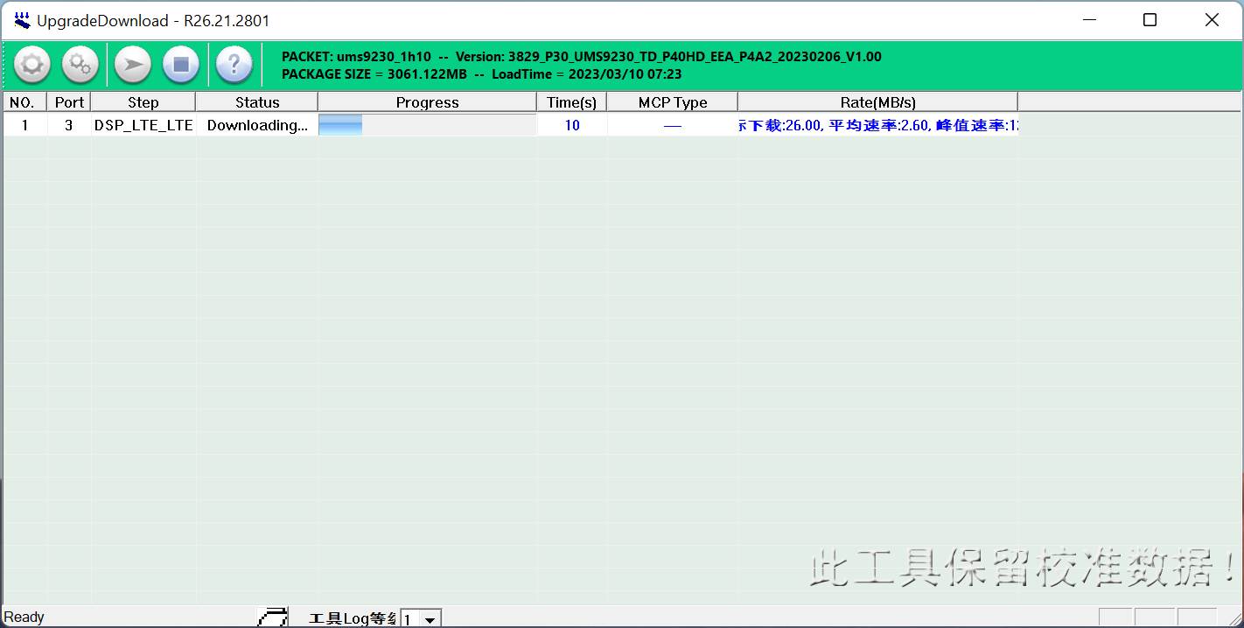

- The entire upgrade process takes about 5 minutes. After the firmware upgrade is complete, as shown in the following figure. Click the “Finsh” icon to exit the program.

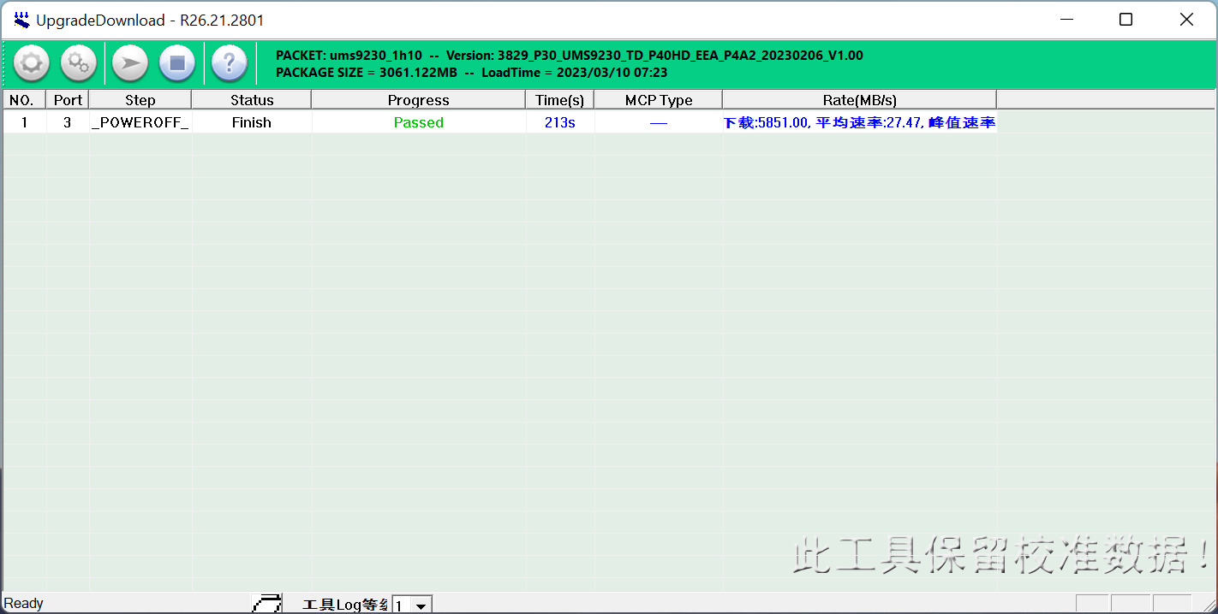

- At this point, the entire upgrade is complete. Unplug the data cable, power on your tablet and wait for it to boot up. The first boot after upgrading the firmware may take longer than usual, so be patient.

Following these steps will ensure a smooth firmware update process and help to avoid any potential issues.

If you have any questions or concerns, please don't hesitate to contact us.

Thank you for choosing Teclast.

