**Teclast Tutorial**

**How to upgrade firmware for your Teclast Tablet (RK CPU)**

Reminder:

Before proceeding with the firmware upgrade, please read these instructions carefully!

It's important to note that there are risks involved in flashing, and it can potentially clear all the data stored on your device. Therefore, it's essential to back up any important data before upgrading.

If there is a Micro SD card in the device, please remove it before beginning the upgrade.

Before starting the firmware update process, make sure to complete the following steps:

1. Locate the ID number on the back of your device, which is comprised of 4 letters and numbers.
2. Download the corresponding firmware package from the official Teclast website. (www.teclast.com) Navigate to the "Support" and "Software Download" sections of the website. Enter your device's ID number to search for and download the corresponding firmware package.



1. Ensure that your device has at least 30% battery power.
2. Turn off any antivirus software on your computer.

Once you have completed the preparatory work, you can proceed with the firmware upgrade process:

**Install the driver:**

1. Open the “Upgrade Driver” folder, find the "DriverInstall" application and double-click to open and run it

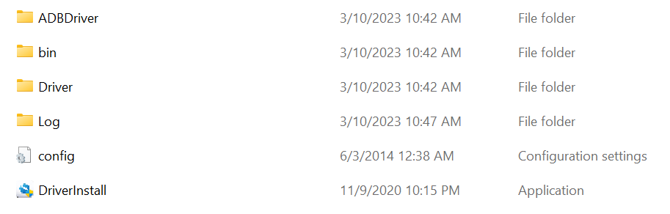

1. Click "Install Driver" to install the driver

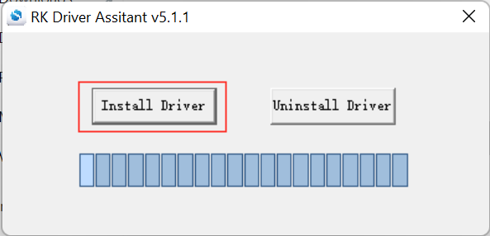

1. During the driver installation process, a prompt similar to the following image will appear. Please select "Install"

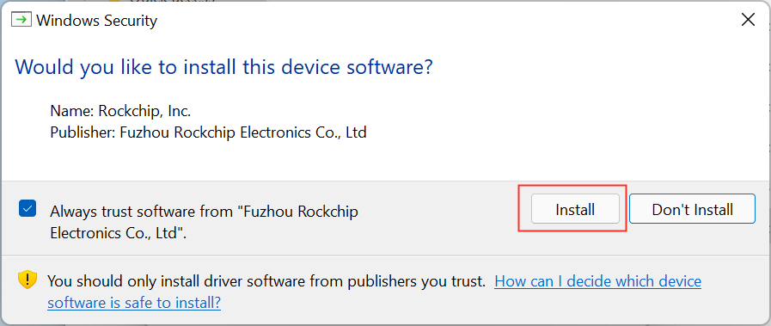

1. After the installation is complete, a prompt similar to the following will appear. Click "OK"

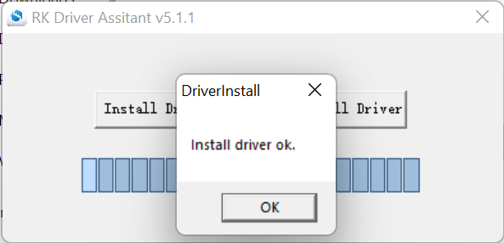

**Install the Firmware:**

1. Open the "Upgrade Tools" folder, find the “RKDevTool” application and double-click to open and run it

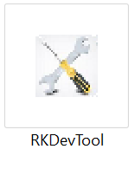

1. The program interface is shown below，click on “Upgrade Firmware”

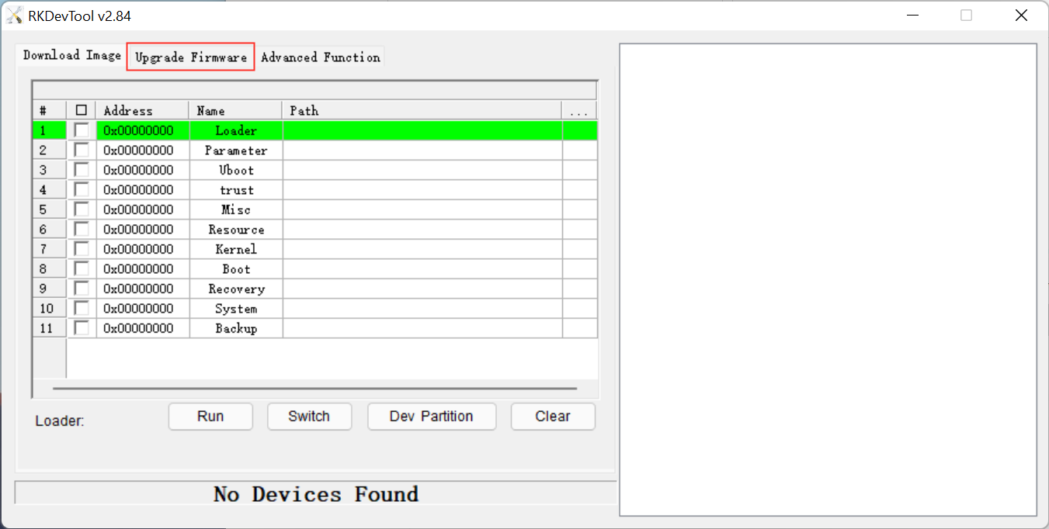

1. Click on the "Firmware" button to load the firmware, as shown in the following image, and select the firmware you want to upgrade

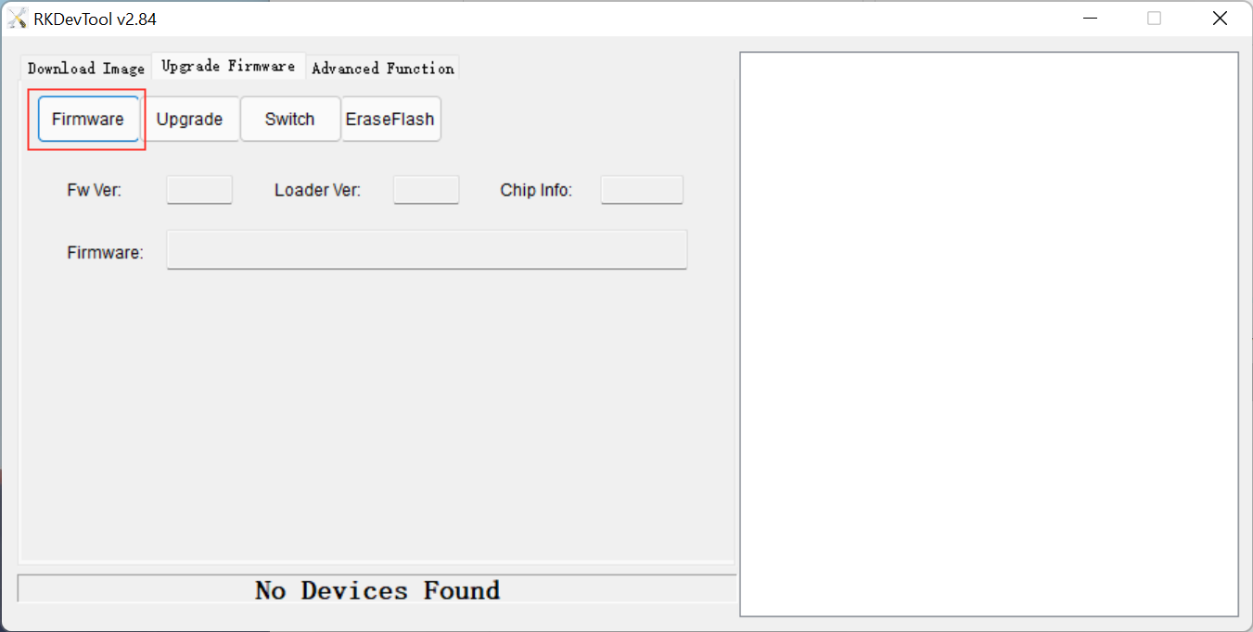

1. In the pop-up dialog box, select the "Firmware.img" file in the "Firmware" folder and open it. Wait for the firmware to finish loading.

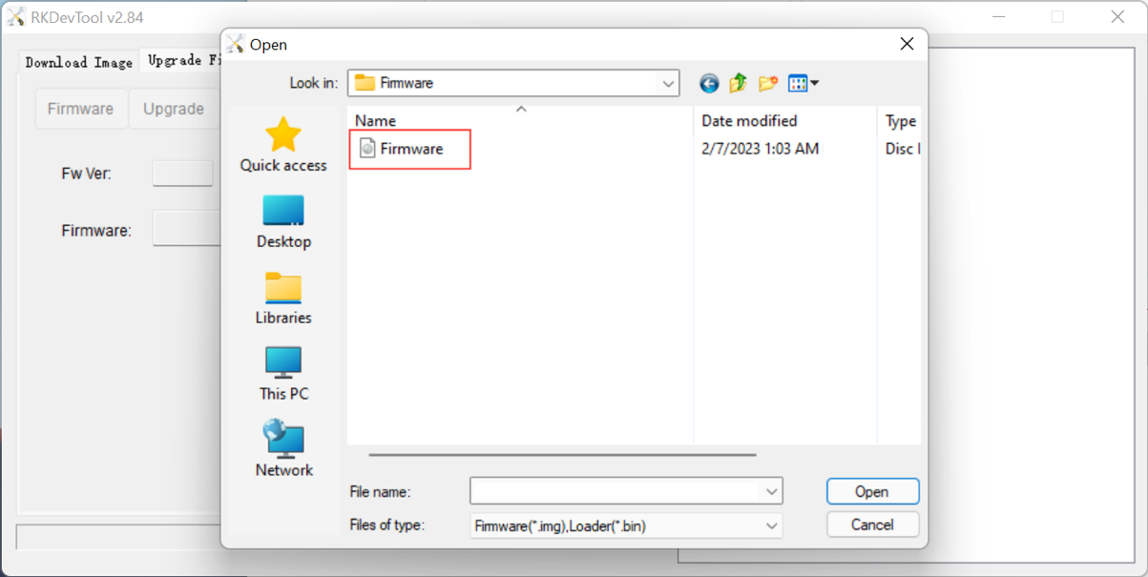

1. After loading is complete, the relevant firmware information will be displayed, as shown in the following image

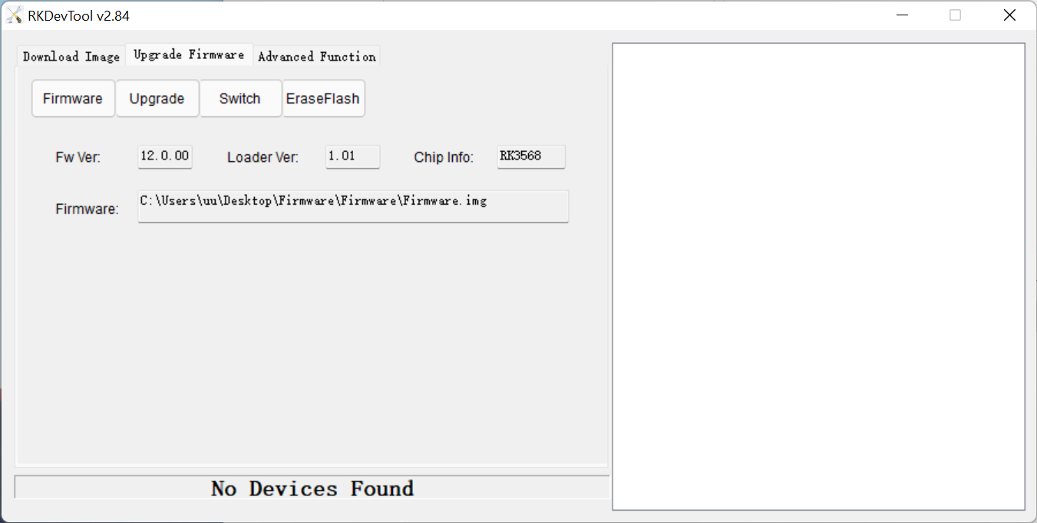

1. Hold down the VOLUME_UP of table then connect with computer. After the program recognizes the tablet, it will prompt "Found One LOADER Device". And you can release the volume down button at this time

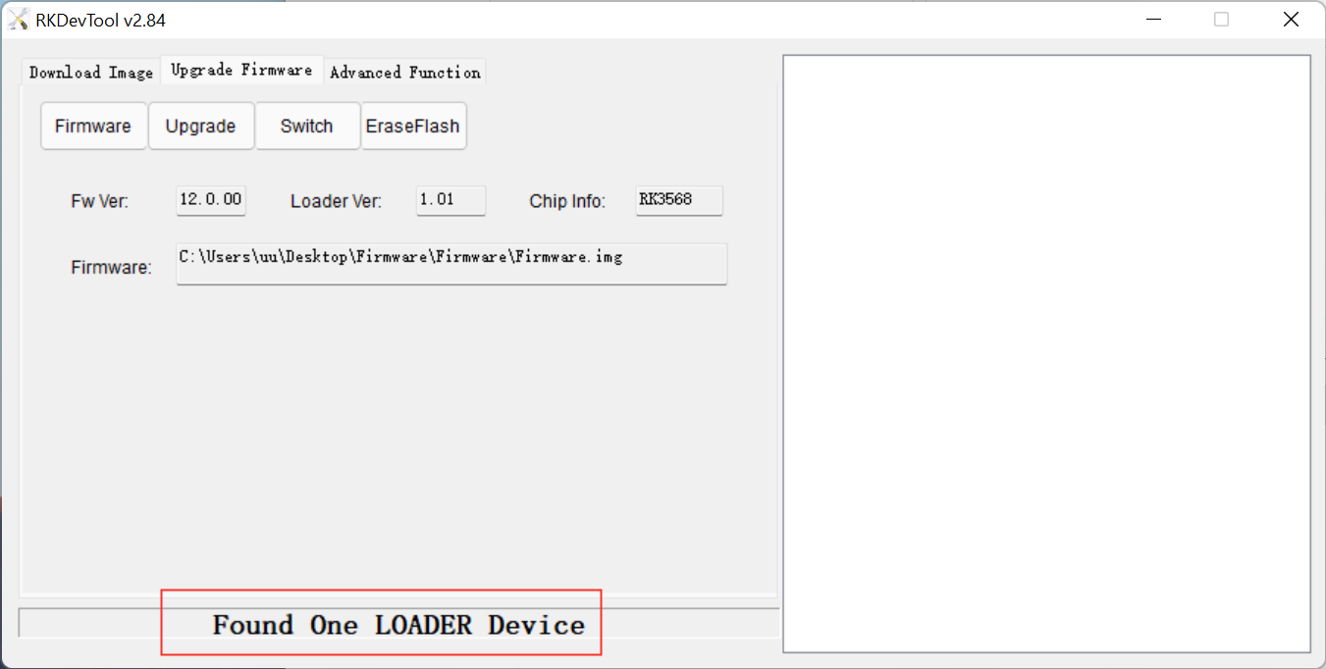

1. Click "Upgrade" to start the upgrade

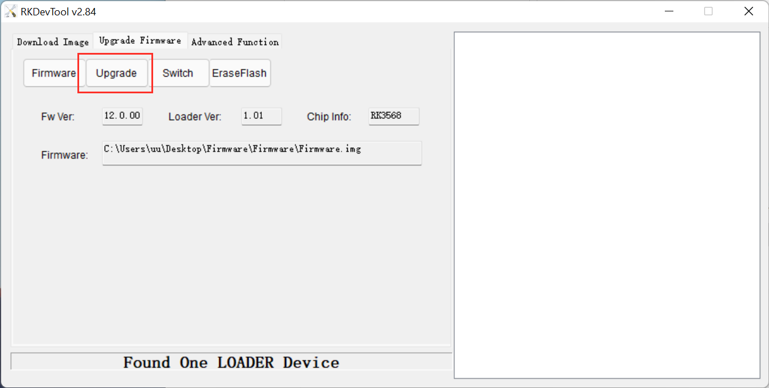

1. The upgrade process is shown in the following image

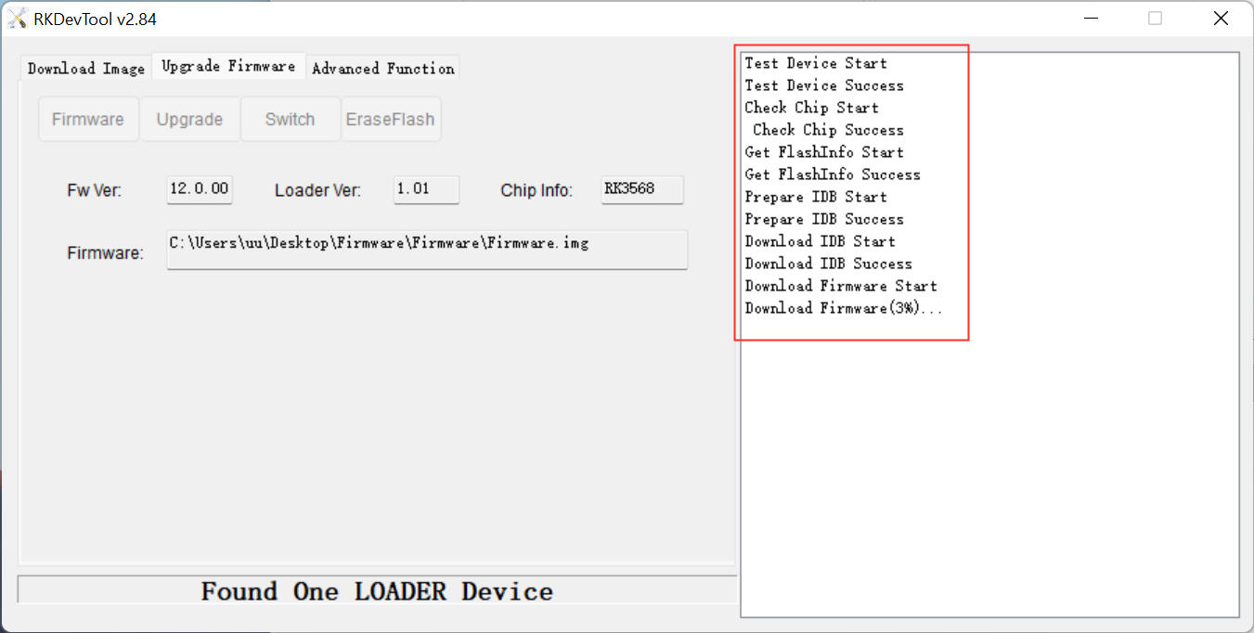

1. The entire upgrade process takes about 5 minutes. After the firmware upgrade is complete, a prompt similar to the following image will appear

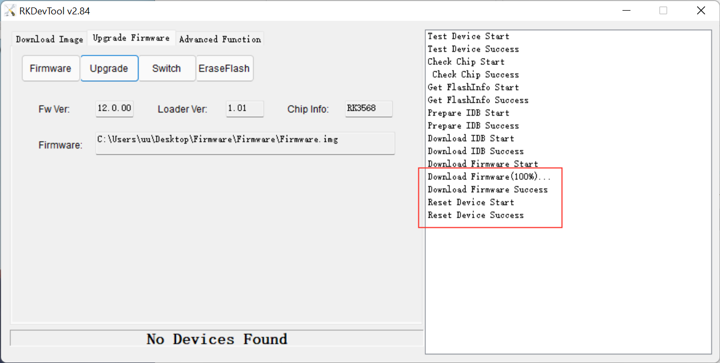

1. After the firmware upgrade is complete, the tablet will automatically power on.

**Following these steps will ensure a smooth firmware update process and help to avoid any potential issues.**

**If you have any questions or concerns, please don't hesitate to contact us.**

**Thank you for choosing Teclast.**