Teclast Tutorial
How to upgrade firmware for your Teclast Tablet (MediaTek CPU)

Before proceeding with the firmware upgrade, please read these instructions carefully!
It's important to note that there are risks involved in flashing, and it can potentially clear all the data stored on your device. Therefore, it's essential to back up any important data before upgrading.
If there is a Micro SD card in the device, please remove it before beginning the upgrade.

Before starting the firmware update process, make sure to complete the following steps:
- Locate the ID number on the back of your device, which is comprised of 4 letters and numbers.
- Download the corresponding firmware package from the official Teclast website. (www.teclast.com) Navigate to the "Support" and "Software Download" sections of the website. Enter your device's ID number to search for and download the corresponding firmware package.
- Ensure that your device has at least 30% battery power.
- Turn off any antivirus software on your computer.

Once you have completed the preparatory work, you can proceed with the firmware upgrade process:

- Open the "Upgrade Tools" folder and find the upgrade program icon. Double-click it to open the "flash_tool."

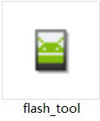 (double-click)

- If you're running this upgrade tool on your computer for the first time, you'll see a prompt appear. Click "OK" to proceed.

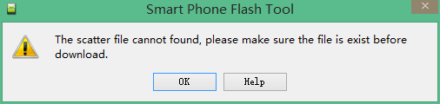
- After clicking "OK," the main interface of the upgrade tool will appear.
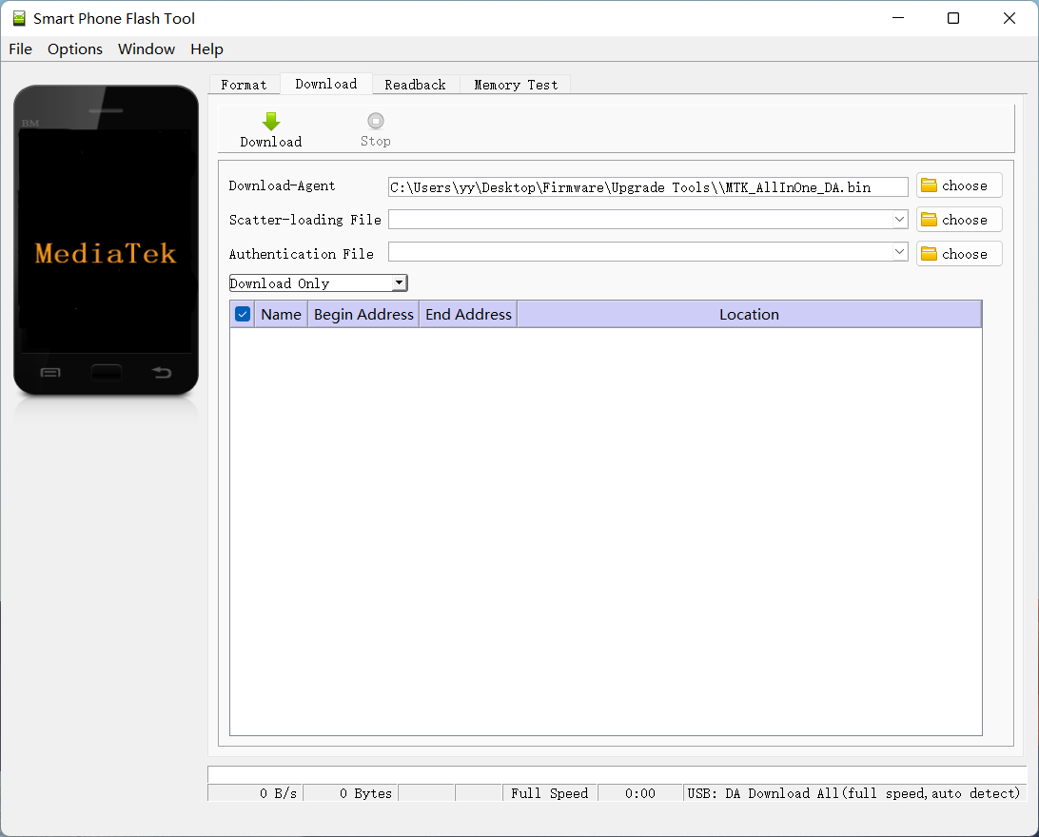

- Click the "Choose" button (red box button) in the "Scatter-loading File" section of the upgrade tool. Select the "Android_scatter.txt" file in the downloaded "Firmware" folder and open it.

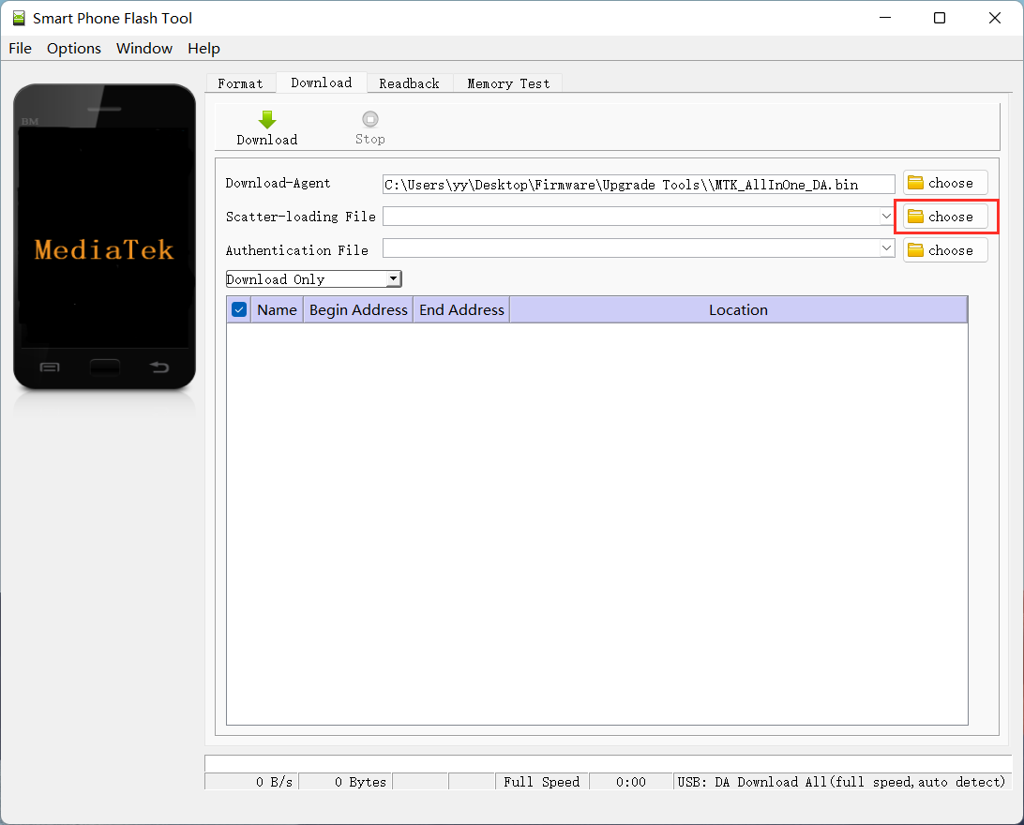

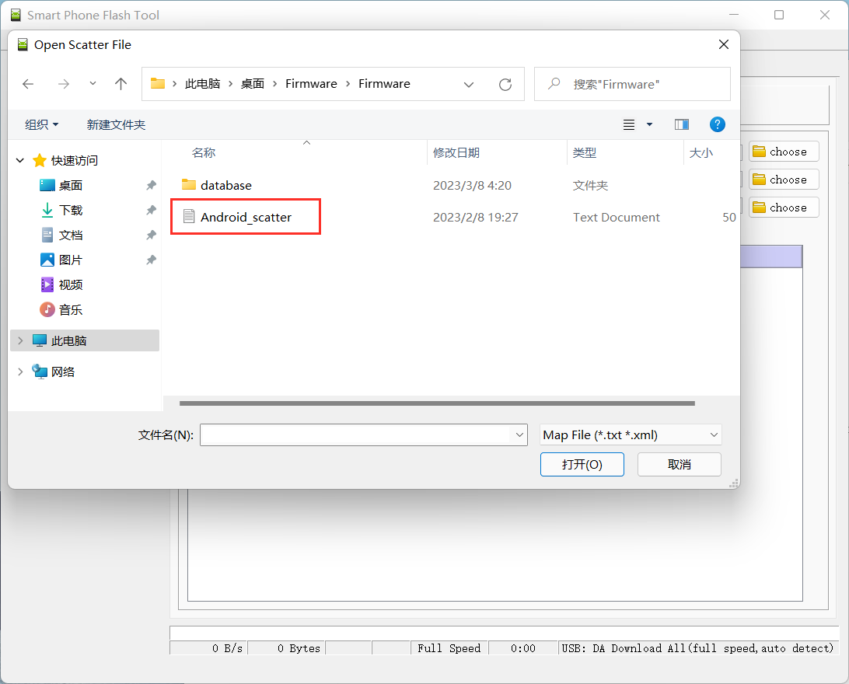

- After selecting "Android_scatter.txt" and loading the firmware, click the "Download" button in the upgrade tool.

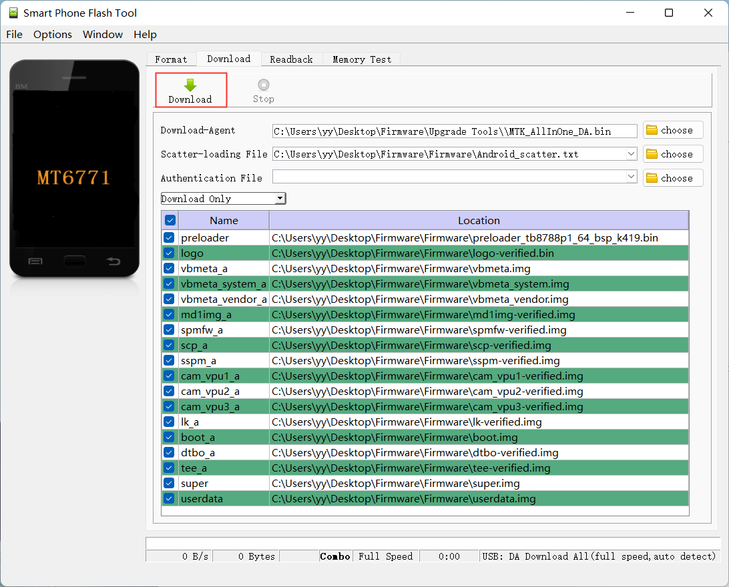

- Turn off the device, connect the USB cable to the computer, and the program will automatically flash the firmware. The flashing process will begin.
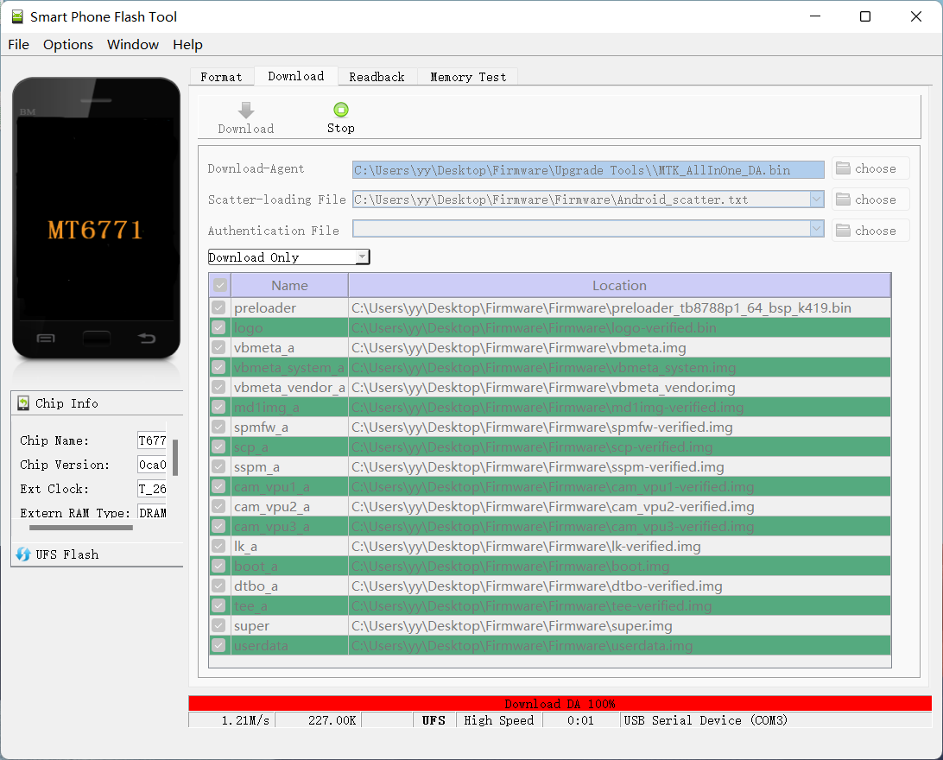

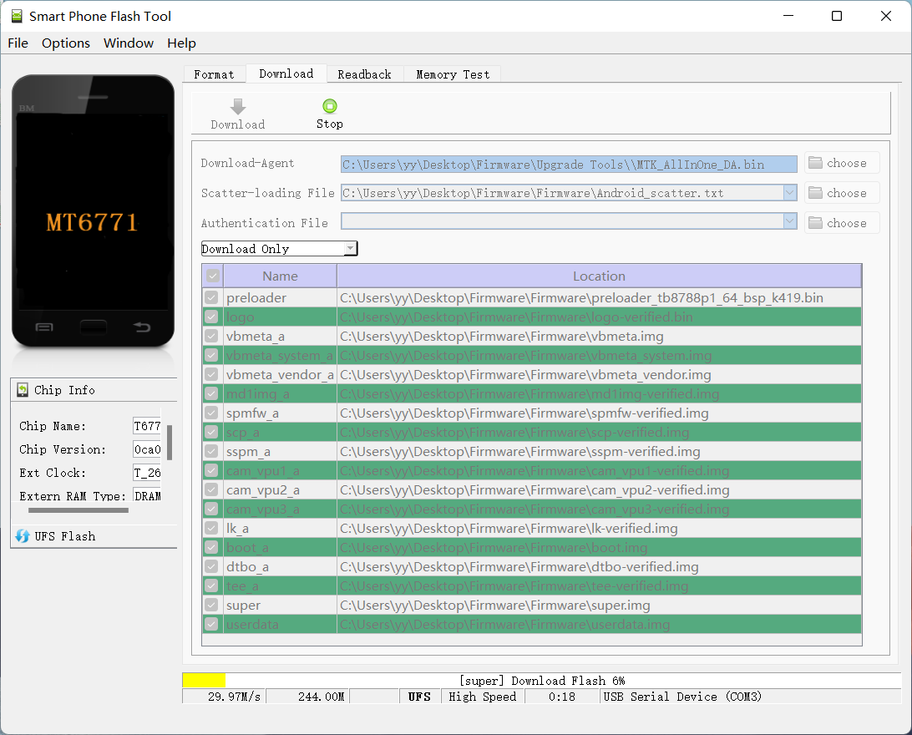

- The entire upgrade process takes about 2 minutes. Wait for the "Download OK" prompt to appear, which signals the upgrade is complete.
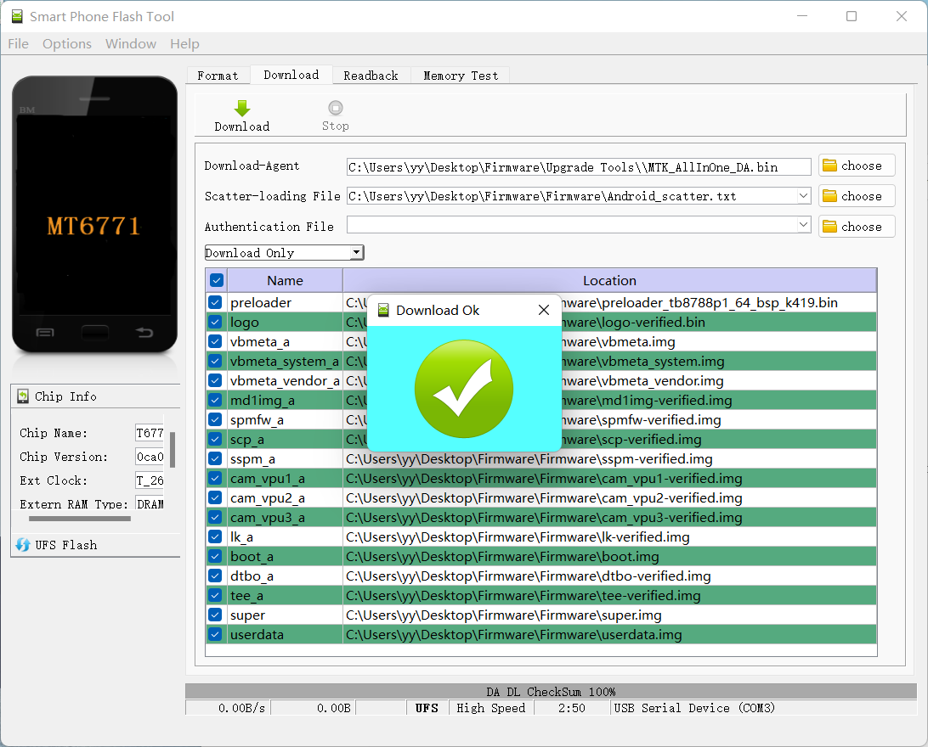

- At this point, the entire upgrade is complete. Unplug the data cable, power on your tablet and wait for it to boot up. The first boot after upgrading the firmware may take longer than usual, so be patient.

Following these steps will ensure a smooth firmware update process and help to avoid any potential issues.

If you have any questions or concerns, please don't hesitate to contact us.

Thank you for choosing Teclast.

